Exploring Centralities

**(1) Popularity contest**

We want to know who the top dolphins are in the network, the real centers of attraction. Using what you learned about centrality from the readings and videos, choose an appropriate centrality measure that will tell us who those dolphins are. Justify your decision and list who the important dolphins are.

In this case, I chose the eigenvector centrality to be the measure, because it is a measure of the influence of nodes in the network based on degree and not just the degree of the node itself but its neighbors. Although we know one of the drawback of this measure is that it can only identify some of the biggest influential node, that is the purpose of this analysis. In this dolphin network, the five most influential dolphins are: 'Grin', 'SN4', 'Topless', 'Scabs', and 'TR99'. If we plot the network and corresponds the size of the node to its eigenvector centrality, we get a graph like the following:

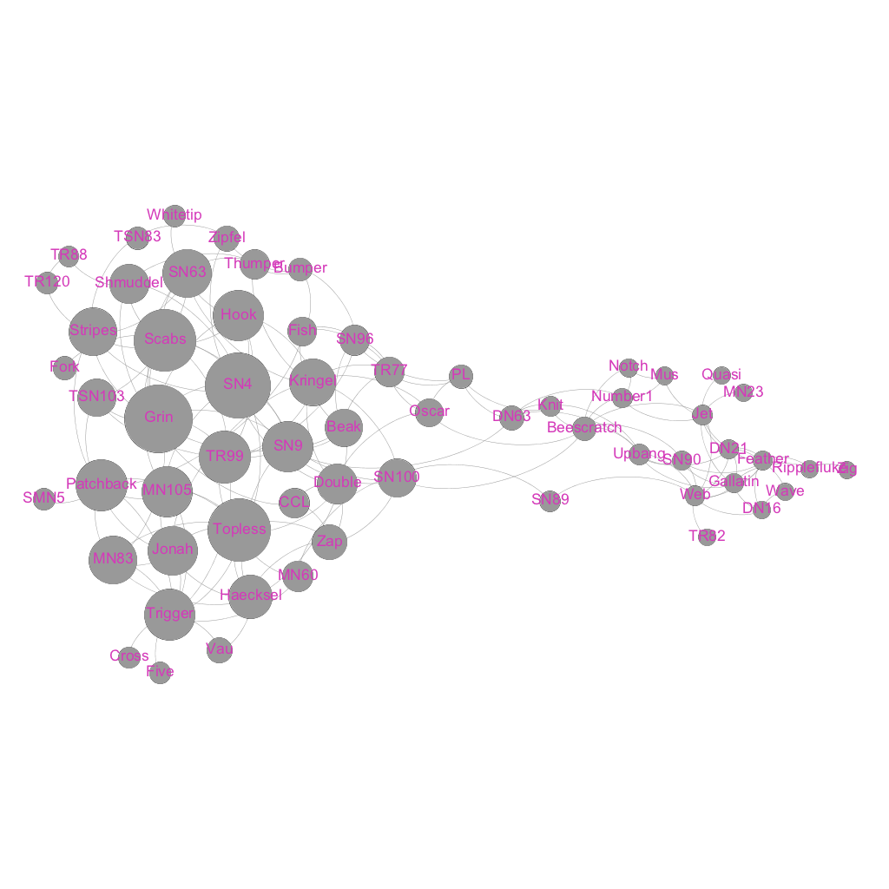

**(2) Relay**

Dolphins like passing information around efficiently along the shortest-paths. Among their neighbors who are the most important message relayers in the network? Justify your centrality choice for finding these dolphins.

In this case, we want to know the dolphin who is the most important message relayers. This fits the definition of betweenness centrality, which quantifies the number of times a node acts as a bridge along the shortest path between two other nodes. According to this measure, the 5 most important message relayers are 'SN100', 'Beescratch', 'SN9', 'SN4', and 'DN63'. If we plot the network and corresponds the size of the node to its betweenness centrality, we get a graph like the following:

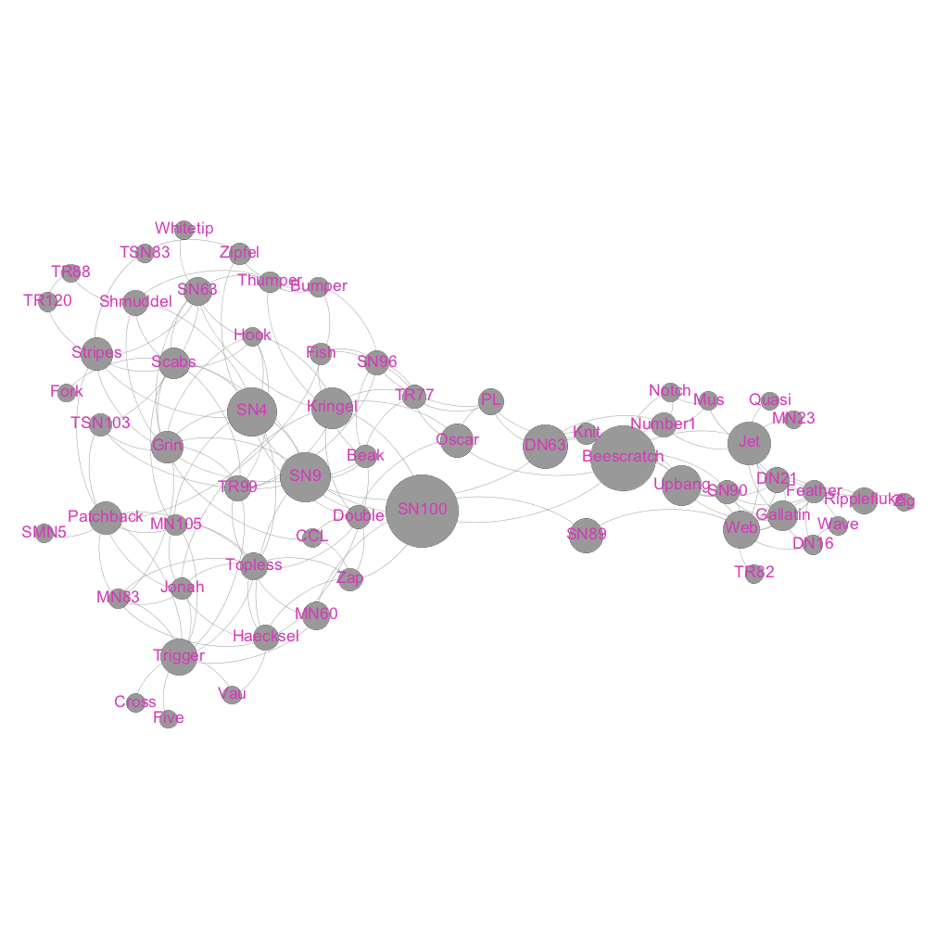

#### (3) Gossip

There is a lot smack going around the pod and everyone wants to know if Flipper will be inviting them to the party next week. But gossip takes time to travel. Which dolphins are in the best position for getting all the best gossip from around the pod? Justify your centrality choice for finding these dolphins.

In the last case, we want to know which dolphins are in the best position for getting all the best gossip from around the pod. I chose closeness centrality as the measure, which is average length of the shortest path between the node and all other nodes in the graph. According to this measure, the 5 best positions for getting all the best gossip from around the pod are 'SN100', 'SN9', 'SN4', 'Kringel', and 'Grin'. If we plot the network and corresponds the size of the node to its closeness centrality, we get a graph like the following:

